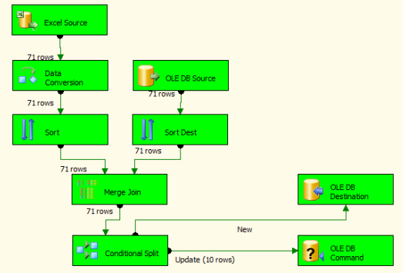

Select "Excel Source" from "Data Flow Sources" and drag it on "Data Flow" tab. Then double click it to assign file source.

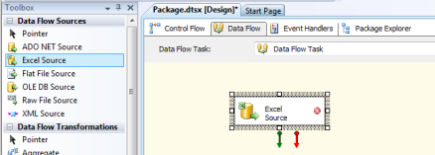

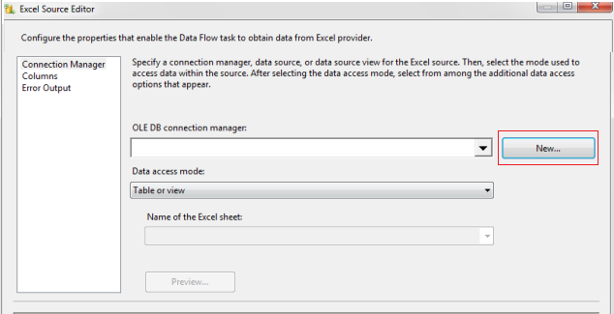

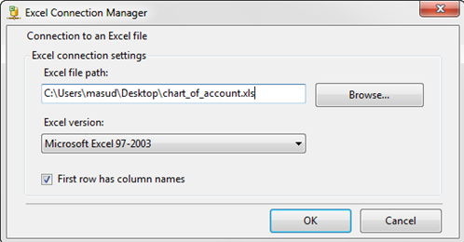

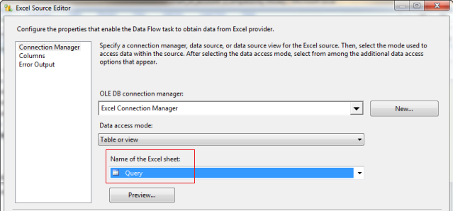

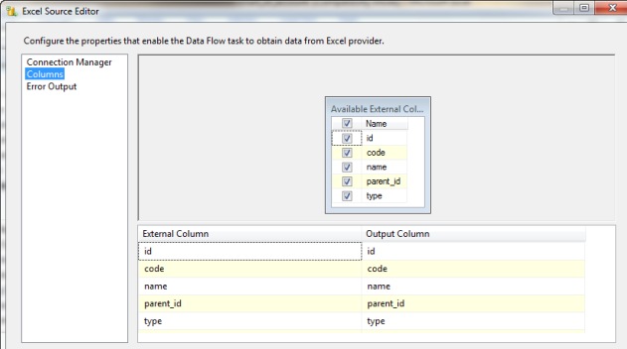

Select "Data Conversion" from "Data Flow Transformation" and drag it on "Control Flow" tab. Connect it from "Excel Source". Then double click it. We need to convert data which is coming from source.

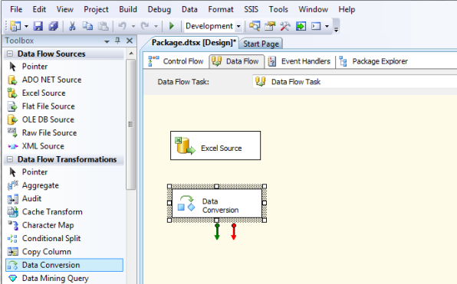

Rename "Output Alias" field, change "Data Type" value from default value to add prefix "src_" to distinguish, and change "Length". Click OK.

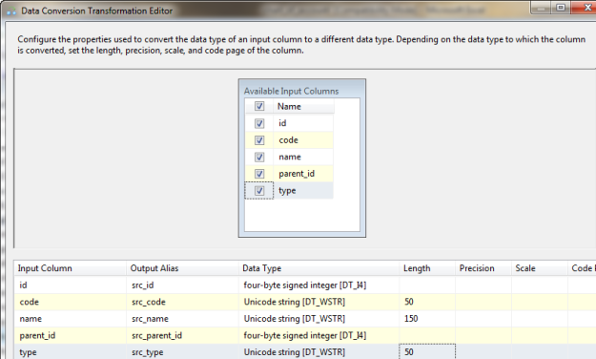

Select "OLE DB Source" from "Data Flow Transformation" and drag it on "Control Flow" tab. Then double click it. We need to assign data source.

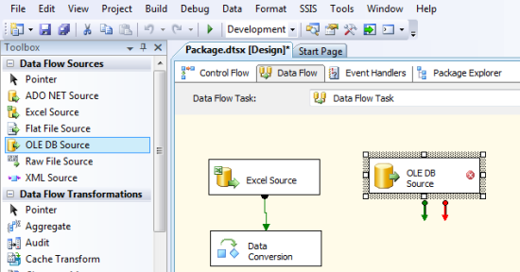

Click New button for create New connection or select from already existing connection.

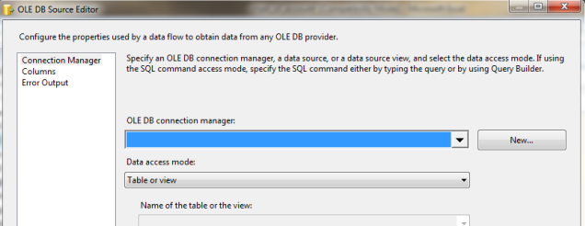

Click New button.

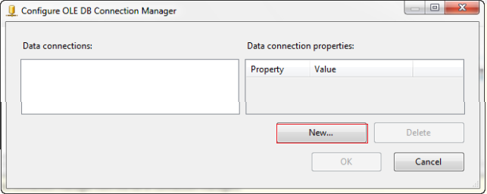

Assign "Server Name", select "Authentication", select "Database", and click "OK".

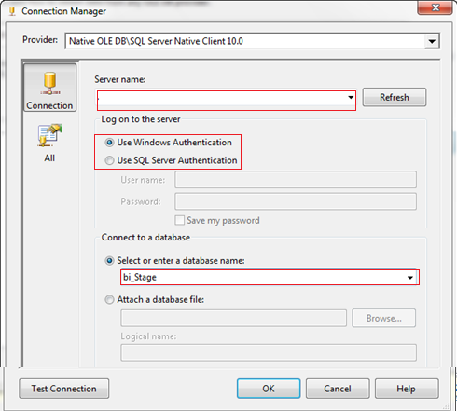

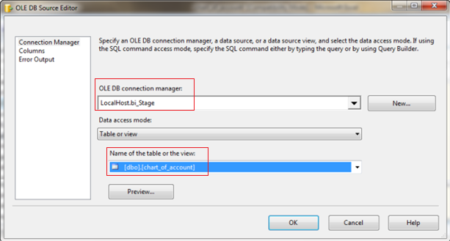

From left tab select "Column" and then click OK.

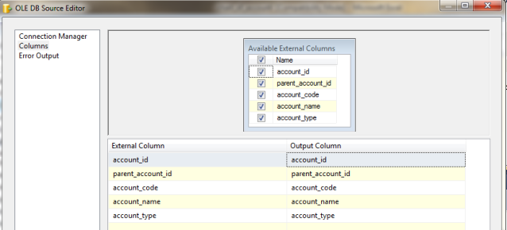

Select "Sort" from "Data Flow Transformation" and drag it on "Control Flow" tab. Connect it from "Data Conversion". Then double click it.

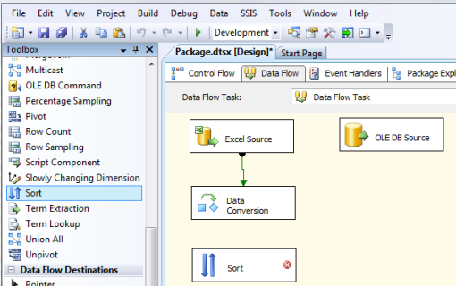

Select column which needs to be sorted.

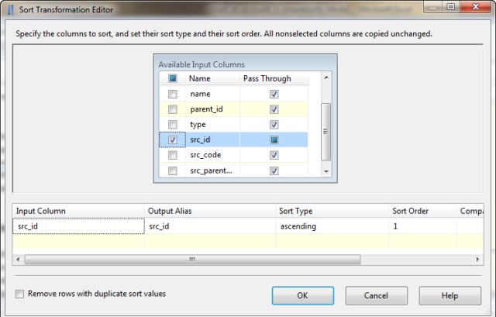

Select another "Sort" from "Data Flow Transformation" and drag it on "Control Flow" tab. Connect it from "OLE DB Source". Then double click it. Select column which needs to be sorted.

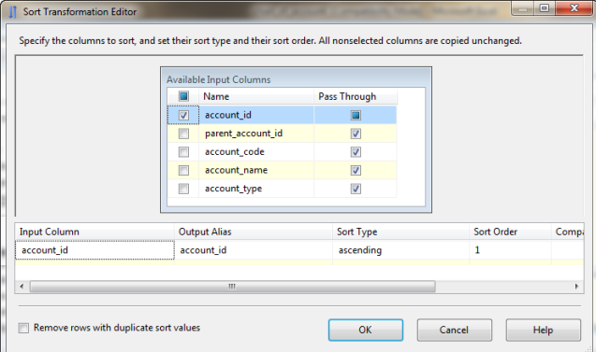

Select "Merge Join" from "Data Flow Transformation" and drag it on "Control Flow" tab. Connect it from "Sort".

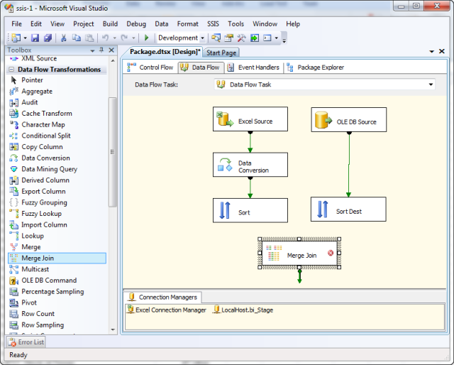

Select Join Type as "Left outer join" and select all fields from left panel and all fields from right panel. Click OK. Connect "Merge Join" from "Sort Dest".

**PREVIOUS SORTS ARE TO MAKE WORKING JOIN FIELDS**

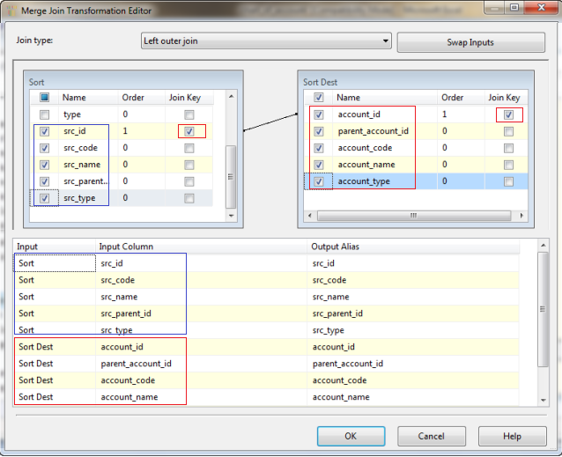

Select "Conditional Split" from "Data Flow Transformation" and drag it on "Control Flow" tab. Connect it from "Merge Join". Right-click the Conditional Split and click Edit to open the Conditional Split Editor.

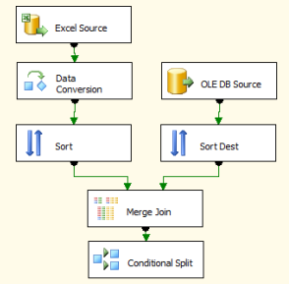

Expand the NULL Functions folder in the upper right of the Conditional Split Transformation Editor. Expand the Columns folder in the upper left side of the Conditional Split Transformation Editor. Click in the "Output Name" column and enter "**New**" as the name of the first output. From the NULL Functions folder, drag and drop the "ISNULL( <<expression>> )" function to the Condition column of the New Rows condition:

Next, drag account_id from the columns folder and drop it onto the "<<expression>>" text in the Condition column. "New" should now be defined by the condition **"ISNULL( [account_id] )".** This defines the WHERE clause for new rows - setting it to "WHERE account_id Is NULL".

Type "**Update**" into a second Output Name column. Add the expression **"((src_code != account_code) || (src_name != account_name) || (src_parent_id != parent_account_id) || (src_type != account_type))"** to the Condition column for the Update Rows output. This defines our WHERE clause for detecting changed rows - setting it to "WHERE ((src_code != account_code) || (src_name != account_name) || (src_parent_id != parent_account_id) || (src_type != account_type))". Note "||" is used to convey "OR" in SSIS Expressions:

Change the "Default output name" from "Conditional Split Default Output" to "Unchanged".

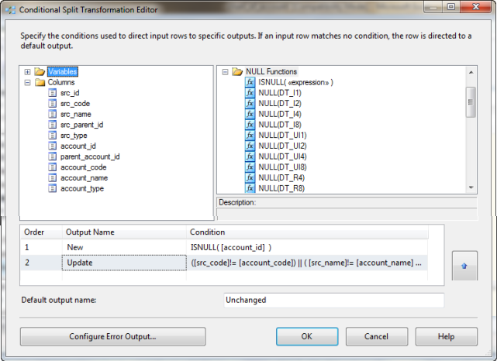

Select "OLE DB Destination" from "Data Flow Destination" and Drag it on "Control Flow" tab.

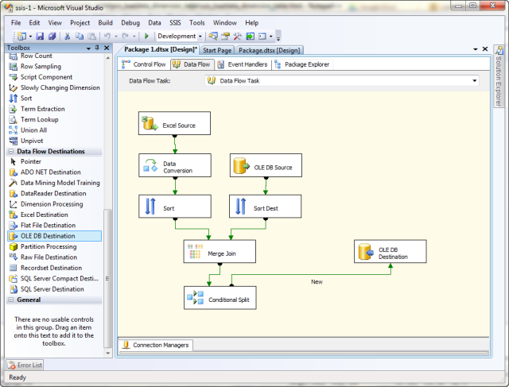

Connect it from "Conditional Split" and select "New" and assign connection and map field.

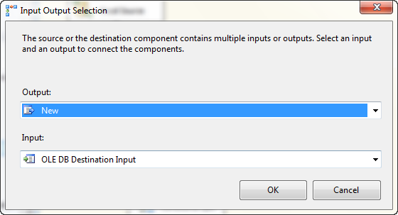

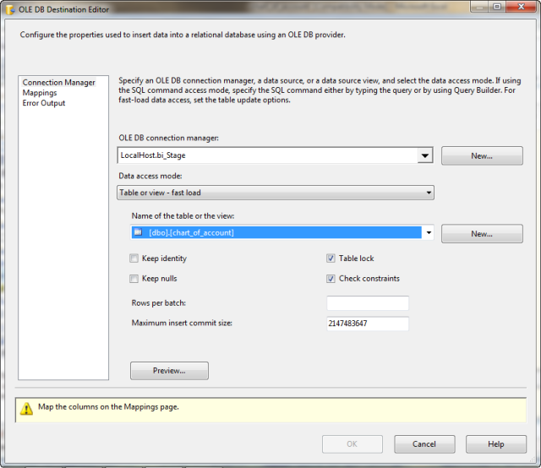

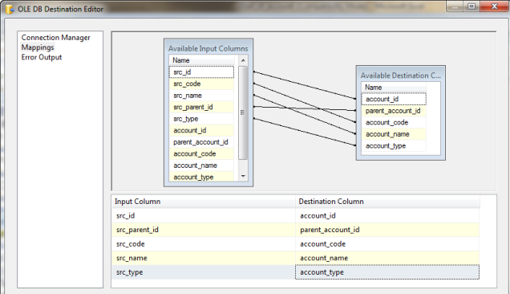

Select "OLE DB Command" from "Data Flow Transformation" and Drag it on "Control Flow" tab.

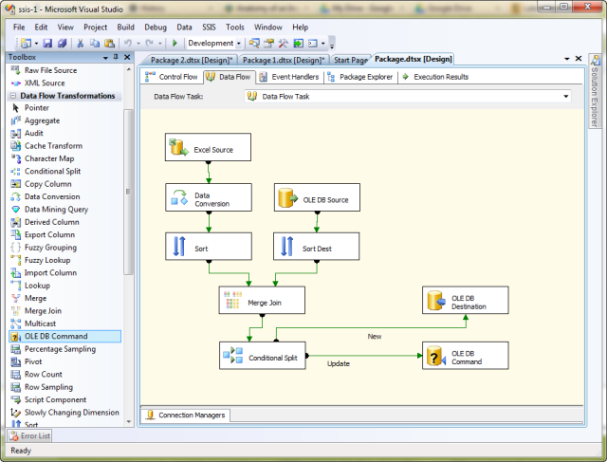

Connect it from "Conditional Split" and select "Update" and assign "Connection Manager" and map field.

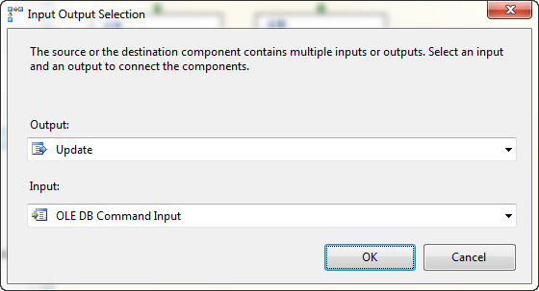

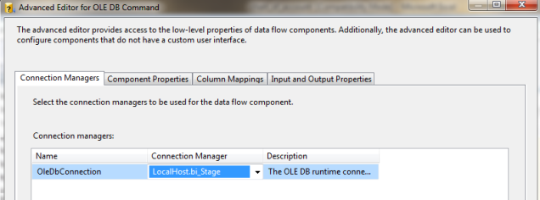

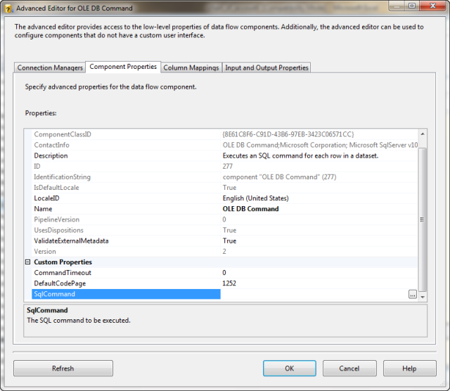

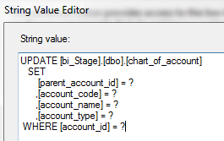

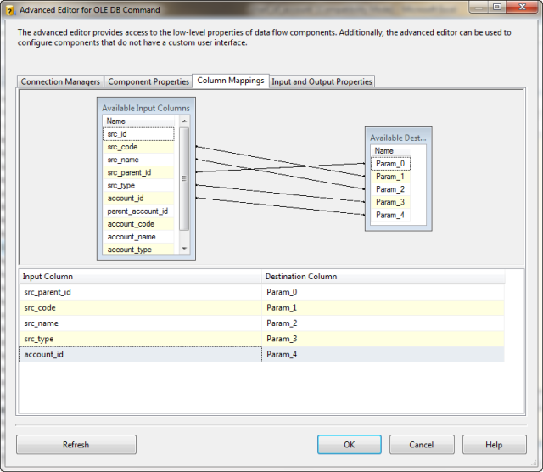

Click OK. Now we are ready to execute the SSIS.

If you execute the package with debugging (press F5), the package should succeed and appear as shown here:

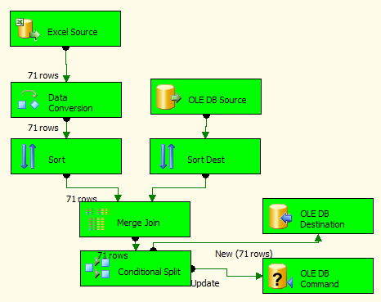

Now Execute the command to test:

SELECT [account_id]

,[parent_account_id]

,[account_code]

,[account_name]

,[account_type]

FROM [bi_Stage].[dbo].[chart_of_account]

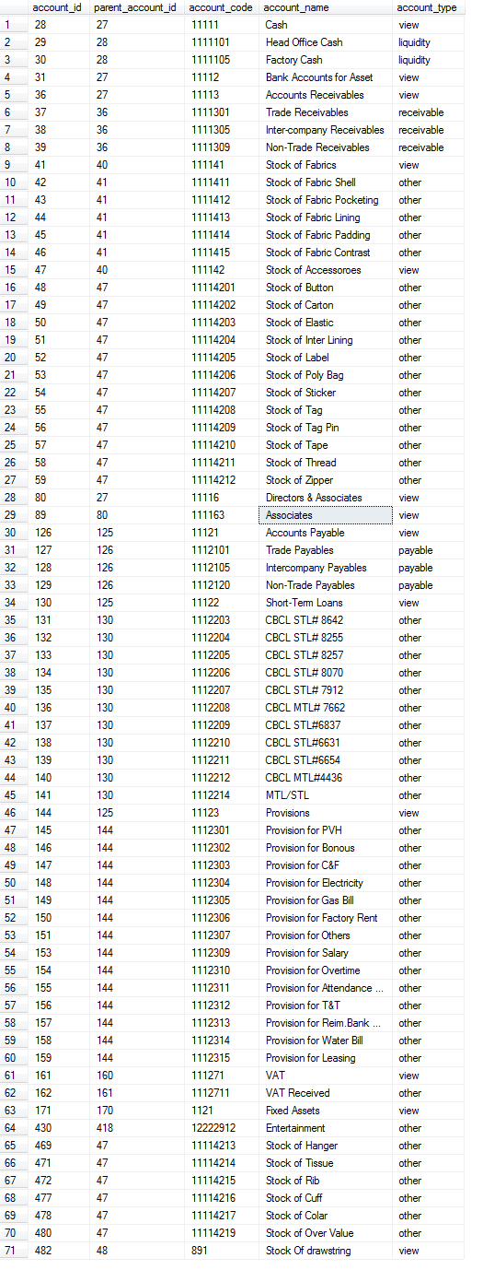

Now I have changed some data in Excel file and again execute the package with debugging (press F5), the package should succeed and appear as shown here:

